

**2X2 Material**

Second Layer

1. To solve the yellow colour

* To reduce to right or left case- R U R’ U R U2 R’
* **Different Patterns**
* Yellow bar on top right with opposite pair

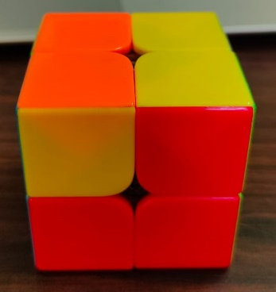

* Checker pattern

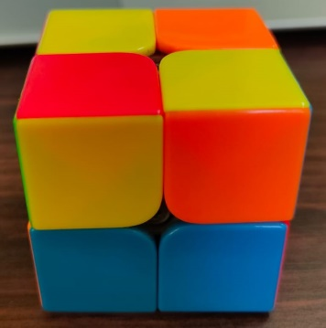

* Opposite bars- One on left the other on right

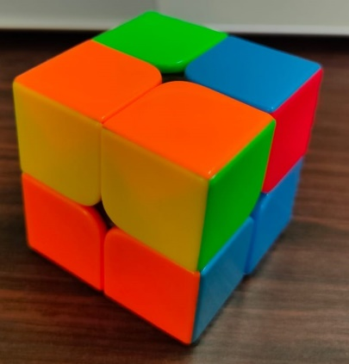 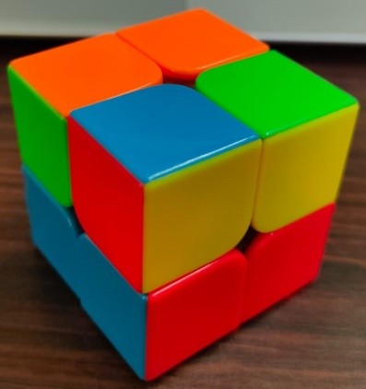 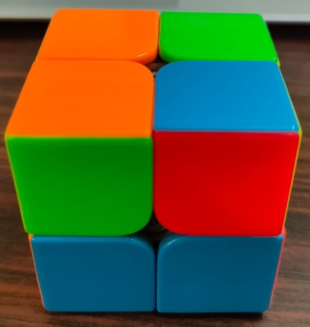



* Yellow bar on left with opposite pair

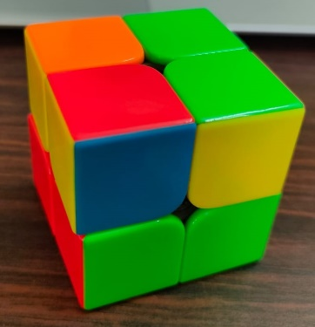

* Two yellow bars on front and the other on top

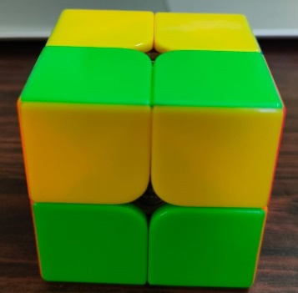

* Left case- L’ U’ L U’ L’ U2 L

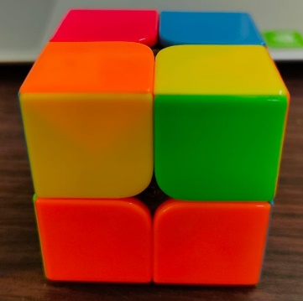

* Right case- R U R’ U R U2 R’

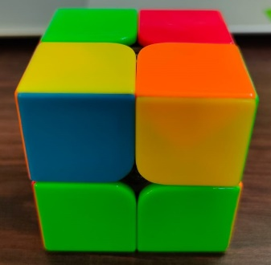



1. To solve the yellow layer

* One solved bar on left- (R U R’ U’) (R’ F R2 U’) R’ U’ (R U R’ F’)

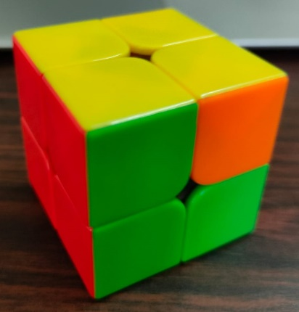

* Diagonal Corners- F (R U’ R’ U’) (R U R’ F’) (R U R’ U’) (R’ F R F’)

